1. Project Introduction & Overview

1.1.1 Descriptions of the project’s tasks and functions

The robot car is a self-driven car that is programmed by the STM32F103RB microcontroller board. It is designed to tackle different driving situations and be able to detect and avoid obstacles. This robot car is an FWD (Front-wheel-drive) four-wheel car. It is controlled and driven by the front two wheels, by adjusting the speed of each of the front wheels, the car can drive forward, turn left, turn right and stop. There are a total of two ultrasonic detectors and one infrared range sensor carried by this car. Each ultrasonic detector is installed at the front of the car with a tilted degree for about 30°. They are responsible for detecting obstacles in the front-left and the front-right. Once the robot car has detected an upcoming obstacle, it will detect whether the opposite direction has any existing obstacle, if not, then the car will manoeuvre itself by turning in the other direction. However, if the way has been totally blocked and the robot car failed to provide a solution, it will buzz to announce that there is no way that it can drive through. The infrared range sensor is responsible for detecting the distance between the car and the obstacle, this is to make sure that this robot car will not turn too early or too late.

1.1.2 Other minor functions

The robot car also consists of LEDs and one LCD display. The LEDs will act as turning signal lights for the two directions, just like any good driver would do, the robot car will always turn its turning signal light on, wait for a few seconds, and then make the turn.

The LCD display is responsible for developing some useful information including the speed of each wheel, the decision that the robot car has made, and it will display some error message whenever there is an error occurs.

The reset button on the microcontroller will also be used, when it is pressed, the robot car will be reset, and this could be useful when some unexpected bugs occurred.

1.1.3 User Controls and Indicators

All behaviours will be directly programmed into the microcontroller, and the robot will be self-driven. The user will not be able to directly control this car at the runtime. However, the behaviours of the car will be able to be modified by the codes. For example, its driving speed.

1.2 Block Diagram

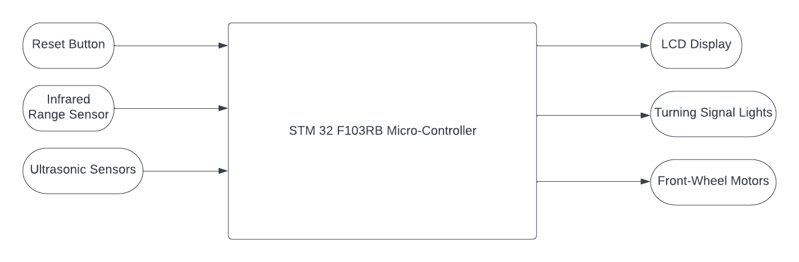

1.3 Sketch of Physical System

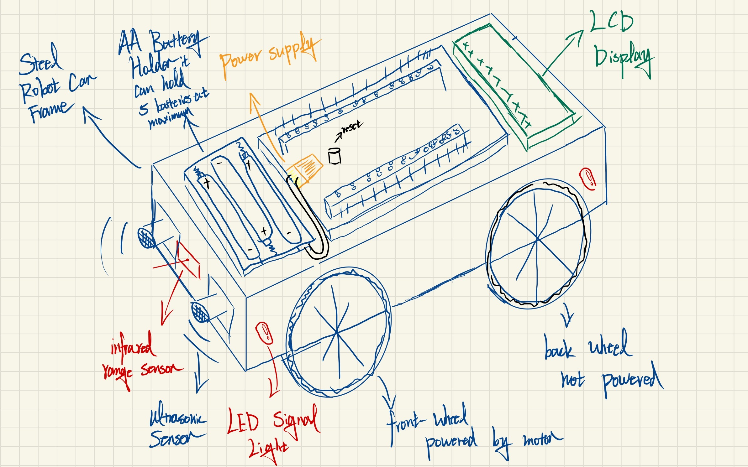

1.4.1 Connection details for all I/O components

The detailed I/O connections are shown in the diagram below, all the PURPLE line indicates that this part is connected to a male pin on the microcontroller by a female jumper wire, all the GREEN line indicates that this part is connected to a female pin of the microcontroller by a male jumper wire, all the GND and VCC have the same properties as the GREEN lines.

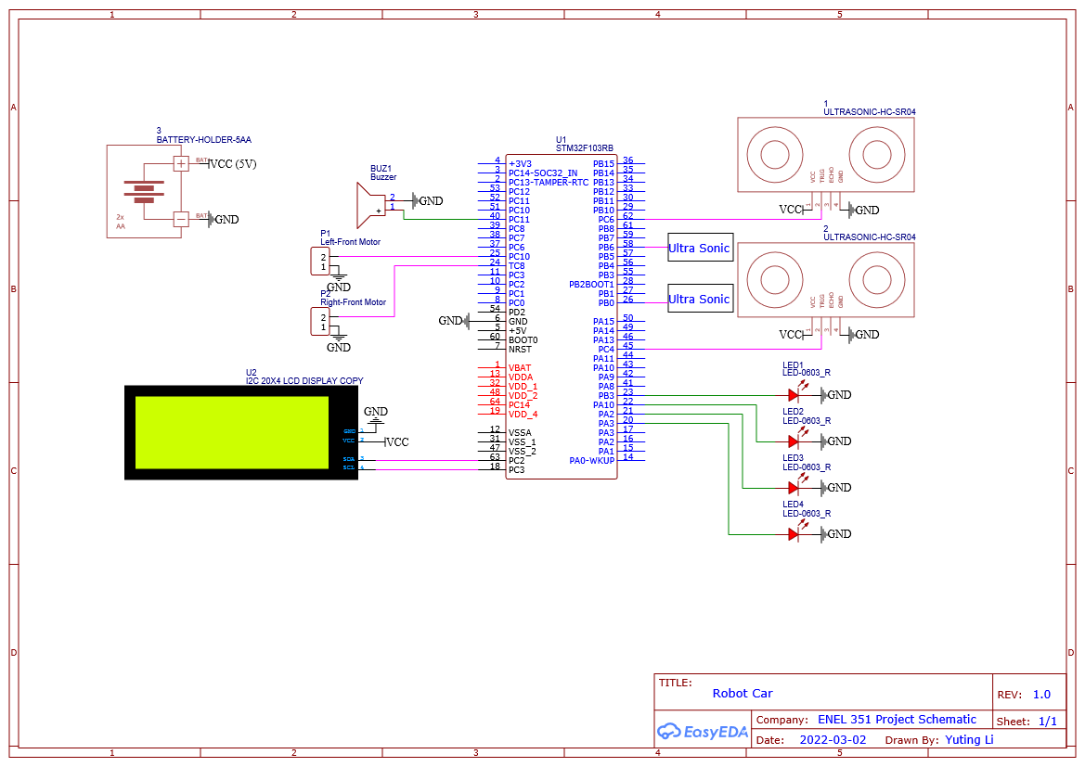

1.4.2 All Electrical Components Properties

|  | Input Voltage | Working Frequency | Supply/Output Voltage | Working Current |
| --- | --- | --- | --- | --- |
| LEDs | 3.3V |  |  |  |
| LCD | 2.5~6V |  |  |  |
| Battery Holder |  |  | 1.5~7.5V (Depending on the # of battery cells) | About 1mA |
| Motor | 3~6V |  |  | 200~400mA |
| Buzzer | No datasheet found, need to be tested | | | |
| Ultrasonic Sensors | 5V | 40Hz | Digital Output | 15mA |
| Infrared Range  Sensors | 3.0~5.3V |  | Analog Output |  |
| STM32F103RB | 5V |  | 3.3V/5V | 300mA |